**EXERCISE 04**

**21 JUNE:**

**Tuesday**

***1NT19IS135***

***SAHANA V***

***C1 BATCH***

Initially create a new project,package and class in eclipse to run a java code

To install jar files

Right click on the project

Click on—-build path—add external archives—hadoop3.2.1—Share

In share

1.Click on common—open hadoo—-common—-3.2.1.jar

2.Click on Mapreduce—-Open hadoop—-mapreduce—-Client—-core—-3.2.1.jar

Right click on project—Export—-Java—Jar file—Next

Browse the address of the java file and save it on desktop and named it .jar

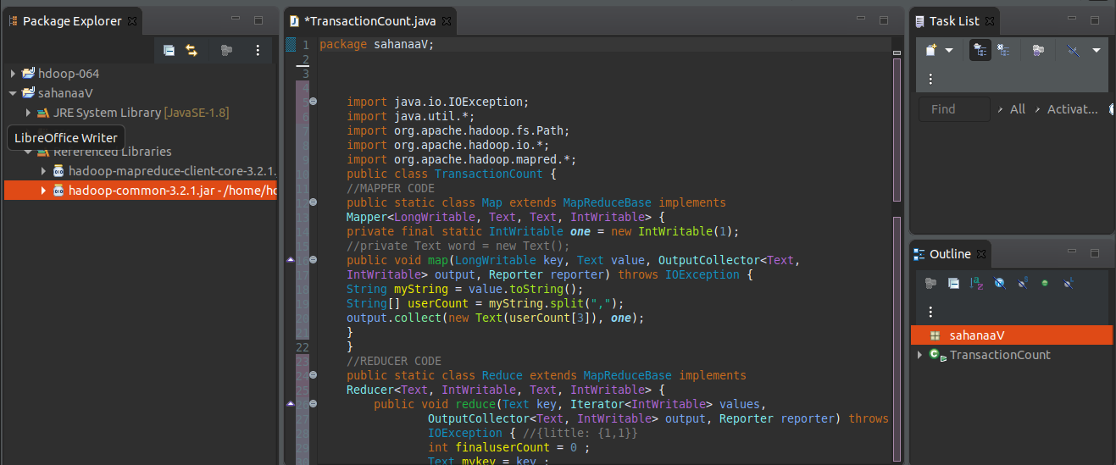

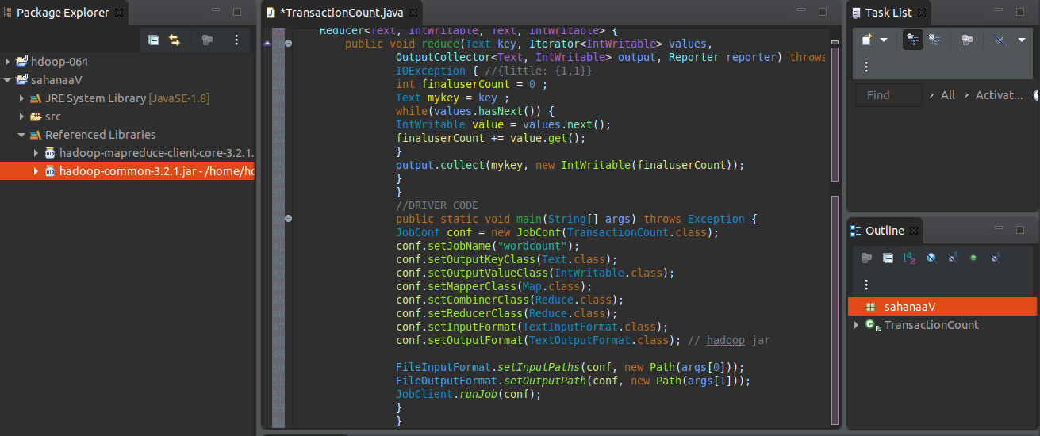

***In the terminal:***

***Run commands***

cd $HADOOP_HOME

cd sbin

start-all.sh

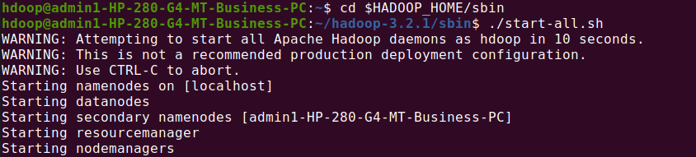

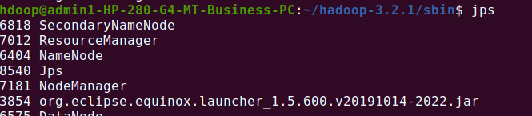

hdfs dfs -mkdir -p /sana

hdfs dfs -copyFromlocal /home/hdoop/Desktop/sahana.csv /sana



Hadoop jar /home/hdoop/Desktop/sahanav.jar ~/sahanaV ~/sana



hadoop jar /home/hdoop/Desktop/sahanaaaV.jar /saana /outputWXYZ

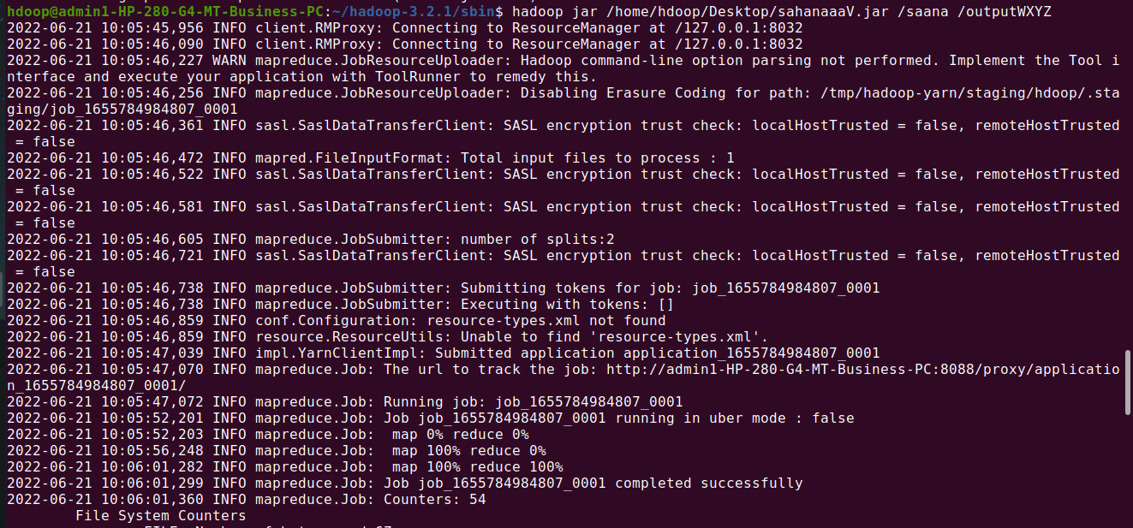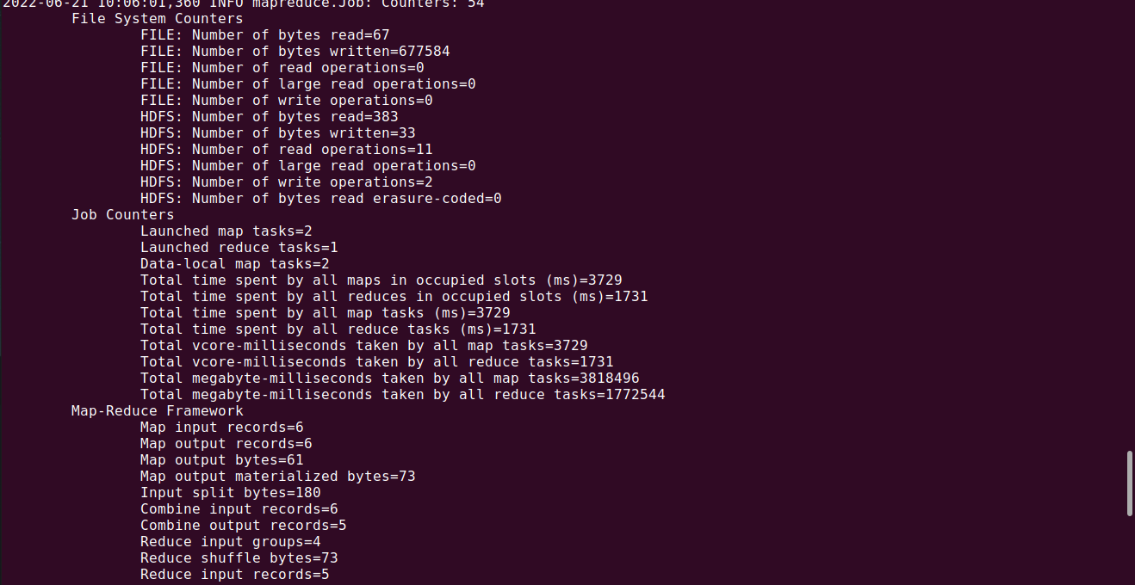

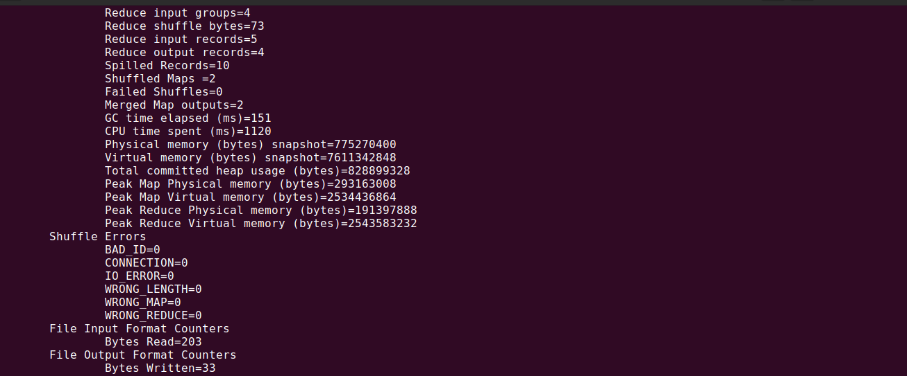

hdfs dfs -cat /outputWXYZ/part*

